**Redesign promo landing page**

**www.atelierultau.ro**

We currently have this webdesign for our landing page (promo page) : <https://www.atelierultau.ro/AT_promo_ofertamai_sculeelectrice_at2020_boschpachete18v.html>

We want to make some changes (updates) in our page (html, css and js if needed) so that in the end our page has *similar functionality* to this page that will be our **model**: <https://www.emag.ro/cmp/outlet-emag/bricolaj-gradinarit.php?ref=section_CMP-61170_5444#echipamente-electrice-scule-unelte>

The main things to change would be:

1. Desktop view: Add the left submenu, with links to different subcategories in the page (only anchors, no page refresh), same behavior as the **model**

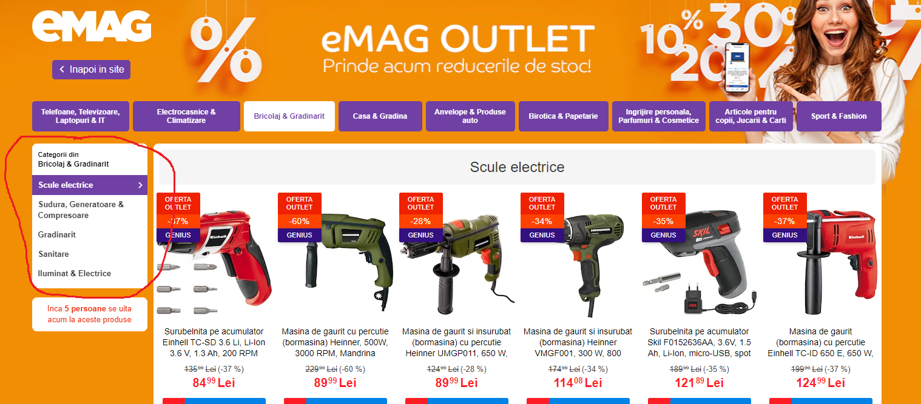

1. Extend the product listing to 6 products / line (currently we have 5/line) , for this we can use the same page width as the model (it seems that our current page is smaller in maximum width)
2. Extend the banner and the top horizontal menu on the full width of the page (so it’s over the left menu):

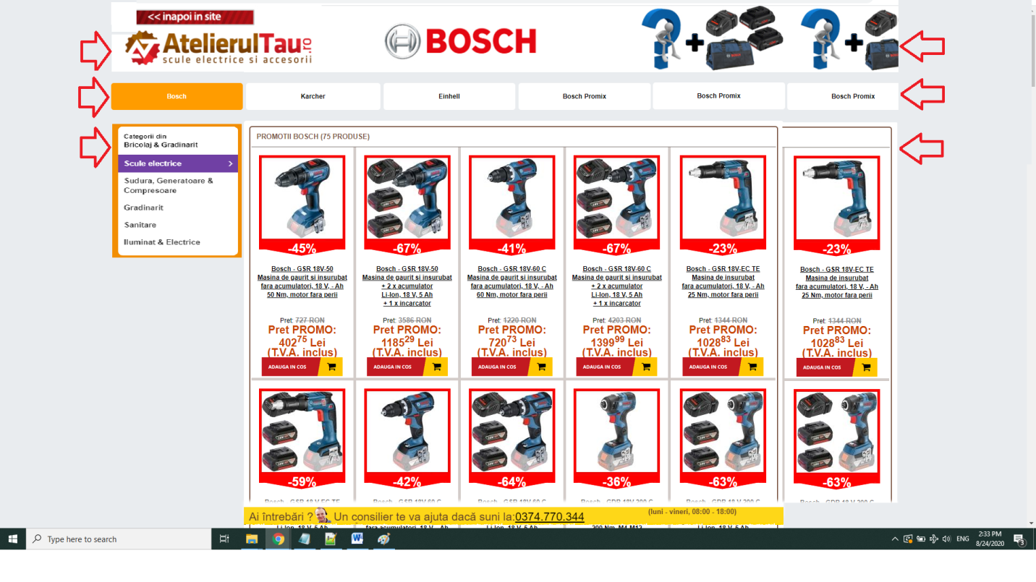

1. For the tablet / mobile view, the products section of the page should behave the same as the **model**: (you can use the same width limits as the **model** for resize purposes)

* 6 products/row on maximum screen width, and, as the client has smaller resolution:
* resize to 5 products/row (left submenu visible),
* resize to 4 products / row (left submenu visible),
* 5 products/row (left submenu *hidden*),
* 3 products / row (left submenu *hidden*),
* 2 products / row (left submenu *hidden*)
* 1 product / row on minimum display size (cell phone).
* insert an image/banner between the tabs for mobile view – please see the mobile version of the **model**. It seems that this “purple genius banner” is hidden in higher resolutions.

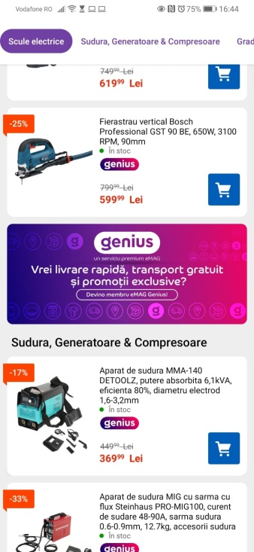

It is not mandatory (but it would be ideal) to copy the behavior of the main menu (horizontal) from the **model**, or if it is very difficult we can use a “sandwich menu” for all smaller resolutions.

1. Add a “go to top” arrow as in the **model** 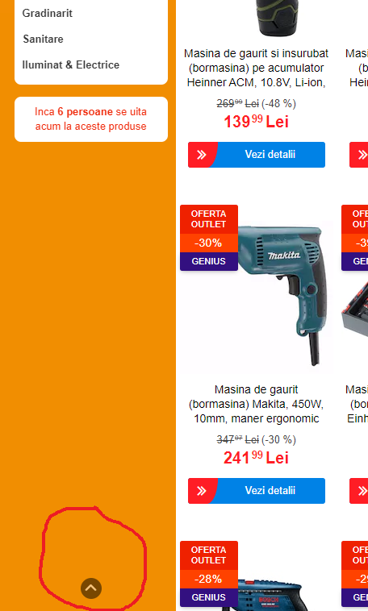
2. For design purposes we want to use the same product box design as in the main categories of the site atelierultau.ro, so we don’t want to use the red box around the products image anymore, and use the design that we currenty have on the main site AtelierulTau.ro (<https://www.atelierultau.ro/scule-electrice-fierastraie-si-utilaje-lemn-fierastraie-circulare-de-masa-c-142_13_1425.html>). So we want to go from this:

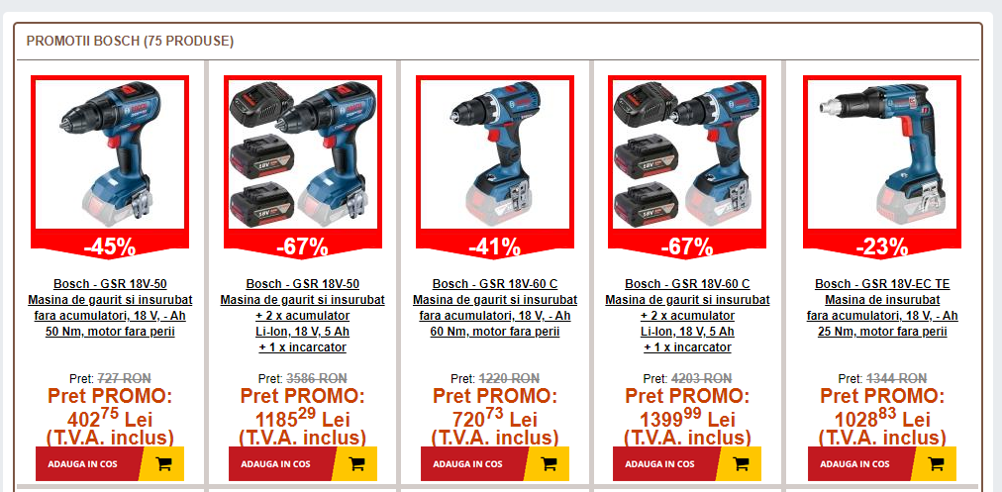

**To something like this:**

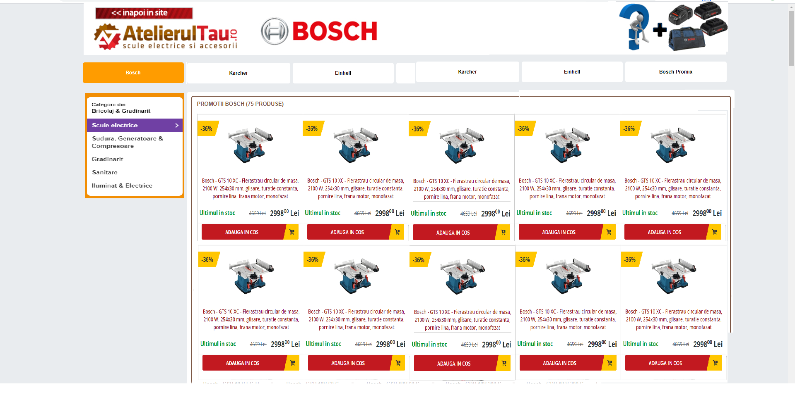The Add to cart button should be always visible (on the site is visible on mouse over), also the text on the products name should always allow the height of 5 rows (all products have 5 rows in the name, <br> is included in the name).

**Important notes:**

Please keep in mind that for server load optimization the images in the page are actually small parts from a big image <https://www.atelierultau.ro/css/12387promo.jpg> and are displayed using background-position . This must remain the same in the updated version of the page.

Please also check the page performance using this tool <https://developers.google.com/speed/pagespeed/insights/?hl=ro&url=https%3A%2F%2Fwww.atelierultau.ro%2FAT_promo_ofertamai_sculeelectrice_at2020_boschpachete18v.html> we want in the end to have similar or better results both for desktop and mobile pages.

The **model** page is only provided to help you to get an idea of our request, you can use it as inspiration but please do not copy paste the source code from them (you can use parts of what is public but not 100%), and under no circumstances use css or js that is in their source code with external links (for example: [https://s13emagst.akamaized.net/layout/ro/cmp/outlet-emag/preview/](https://s13emagst.akamaized.net/layout/ro/cmp/outlet-emag/preview/campaign.css?1598443549) ….. )

However you can use by copy-paste all css/js/html you can find on www.atelierultau.ro, as this is our property.

You can use whatever approach you find easy – either rewrite the code from zero, or use current html code and only add/replace the current css, js and html, we only care about the final product.

No PHP knowledge is needed, only basic css, html and js, as the page is static HTML (this is all we want for this project), once we have the working HTML we will open a new project to integrate the HTML with PHP.